**Expert ID/Name: Nstructive**

**Date: 09-Nov-2020**

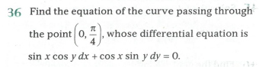

**Answer:**

|  |
| --- |
| **Section 1:** Algorithm/Theorem Reminder / A tip for solving these type of questions |
| **Tips:**  1. Separate the terms of.  2. Apply the integration on both sides.  3. |

|  |
| --- |
| **Section 2:** Step-by-step answer |
| Given: The differential equation is  To find: Equation of the curve passing through the point .  Step 1:   |  |  | | --- | --- | | Instruction | Separate the terms of . | | Calculation |  |   Step 2:   |  |  | | --- | --- | | Instruction | Apply the integration on both sides | | Calculation | Which is passing through the point . |   Step 3:   |  |  | | --- | --- | | Instruction | Take in | | Calculation |  |   Step4:   |  |  | | --- | --- | | Instruction | Substitute in | | Calculation | Which is the required equation of curve. | |

|  |
| --- |
| **Section 3** |
| Final answer:  Hence, verified. |